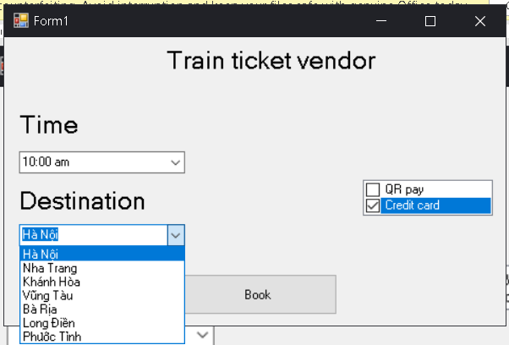

At this step, user will choose time , destination and payment options then press Book.

If user choosed Credit card:

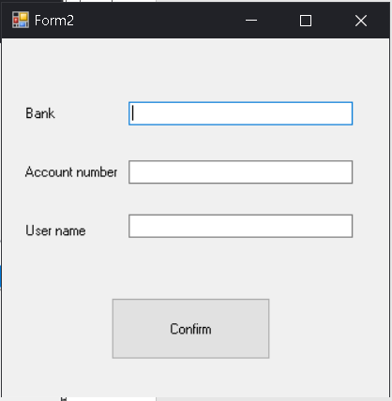

They will need to input credit card information then do payment.

If user choosed QR pay:

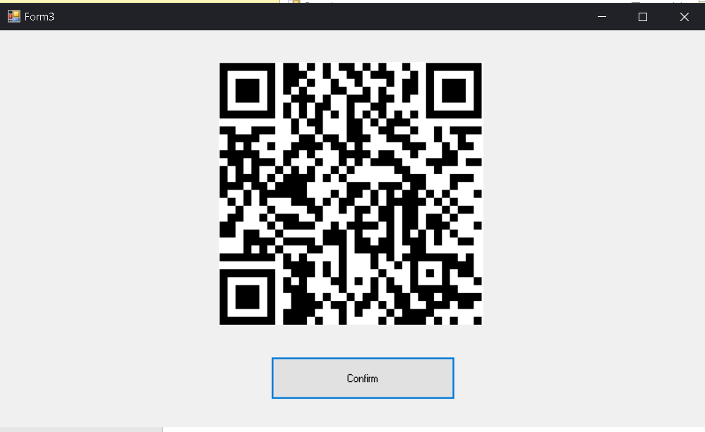

It will appear a QR code for user to scan, (don’t scan pls) then press confirm after scanned and did the payment.